11/13/2022

Event Parking Management

Full Stack Web Development With 3rd Party API

Table of Contents

1. Project Scope 2

1.1. User Flow Diagram 2

2. Navigation Menu 3

3. Parking Registration Form 4

3.1. Add New Parking 4

3.2. View Added Parking 4

3.3. Update Parking Information 5

3.4. Delete Parking Information 5

4. User Registration Form 6

4.1. Add New User 6

4.2. View User Information 6

4.3. Update User Information 7

4.4. Delete User Information 7

5. Vehicle Registration Form 8

5.1. Add New Vehicle 8

5.2. View Vehicle Information 8

5.3. Update Vehicle Information 9

5.4. Delete Vehicle Information 9

6. Book Parking Slot 10

6.1. Book Parking Slot 10

6.2. View Parking Slots 10

6.3. Update Parking Slot information 11

6.4. Delete Parking Slot Information 11

**7. 3rd Party API Integration[Google Maps]**

## Project Scope

|  |  |  |  |
| --- | --- | --- | --- |
| **Event Parking Management** | | | |
| **Parking Registration** | **User Registration** | **Vehicle Registration** | **Book Parking Slot** |
| C: Creating the Parking  R: View Parking  U: Update Parking Details  D: Delete Parking | C: Registering Users  R: View User Details  U: Update User Details  D: Delete User | C: Registering the vehicle  R: View Vehicle Details  U: Update Vehicle Details  D: Delete Vehicle | C: Booking the Parking  R: My Bookings  U: Update Booking  D: Leave Parking |
| **Google Maps** | | | |

### User Flow Diagram

Below is the user flow diagram for Event Parking Management Project.

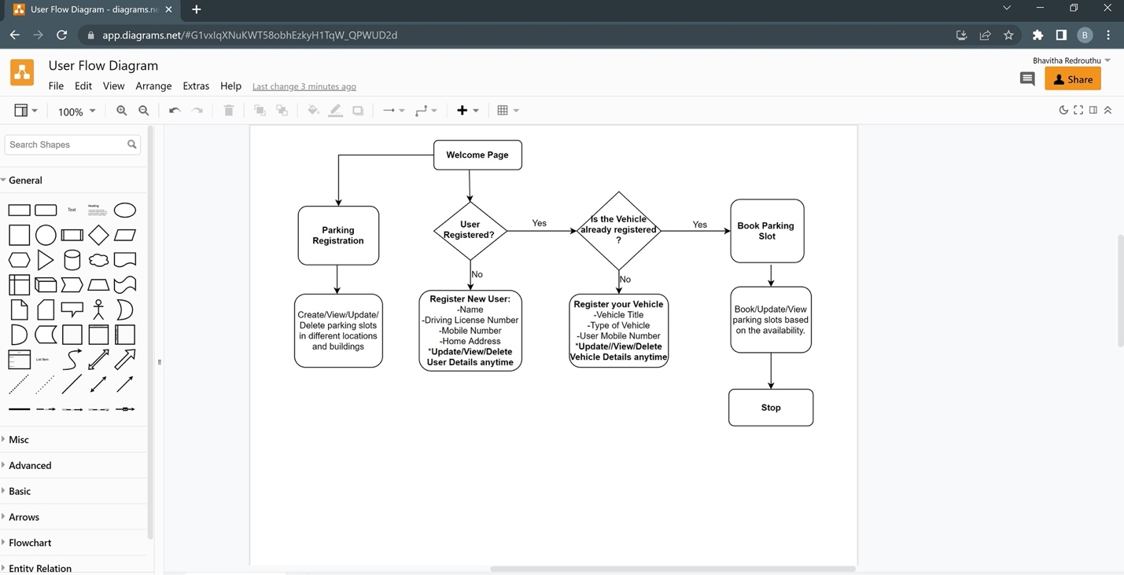

## Navigation Menu

Navigation menu makes it easier for user to navigate through the forms.

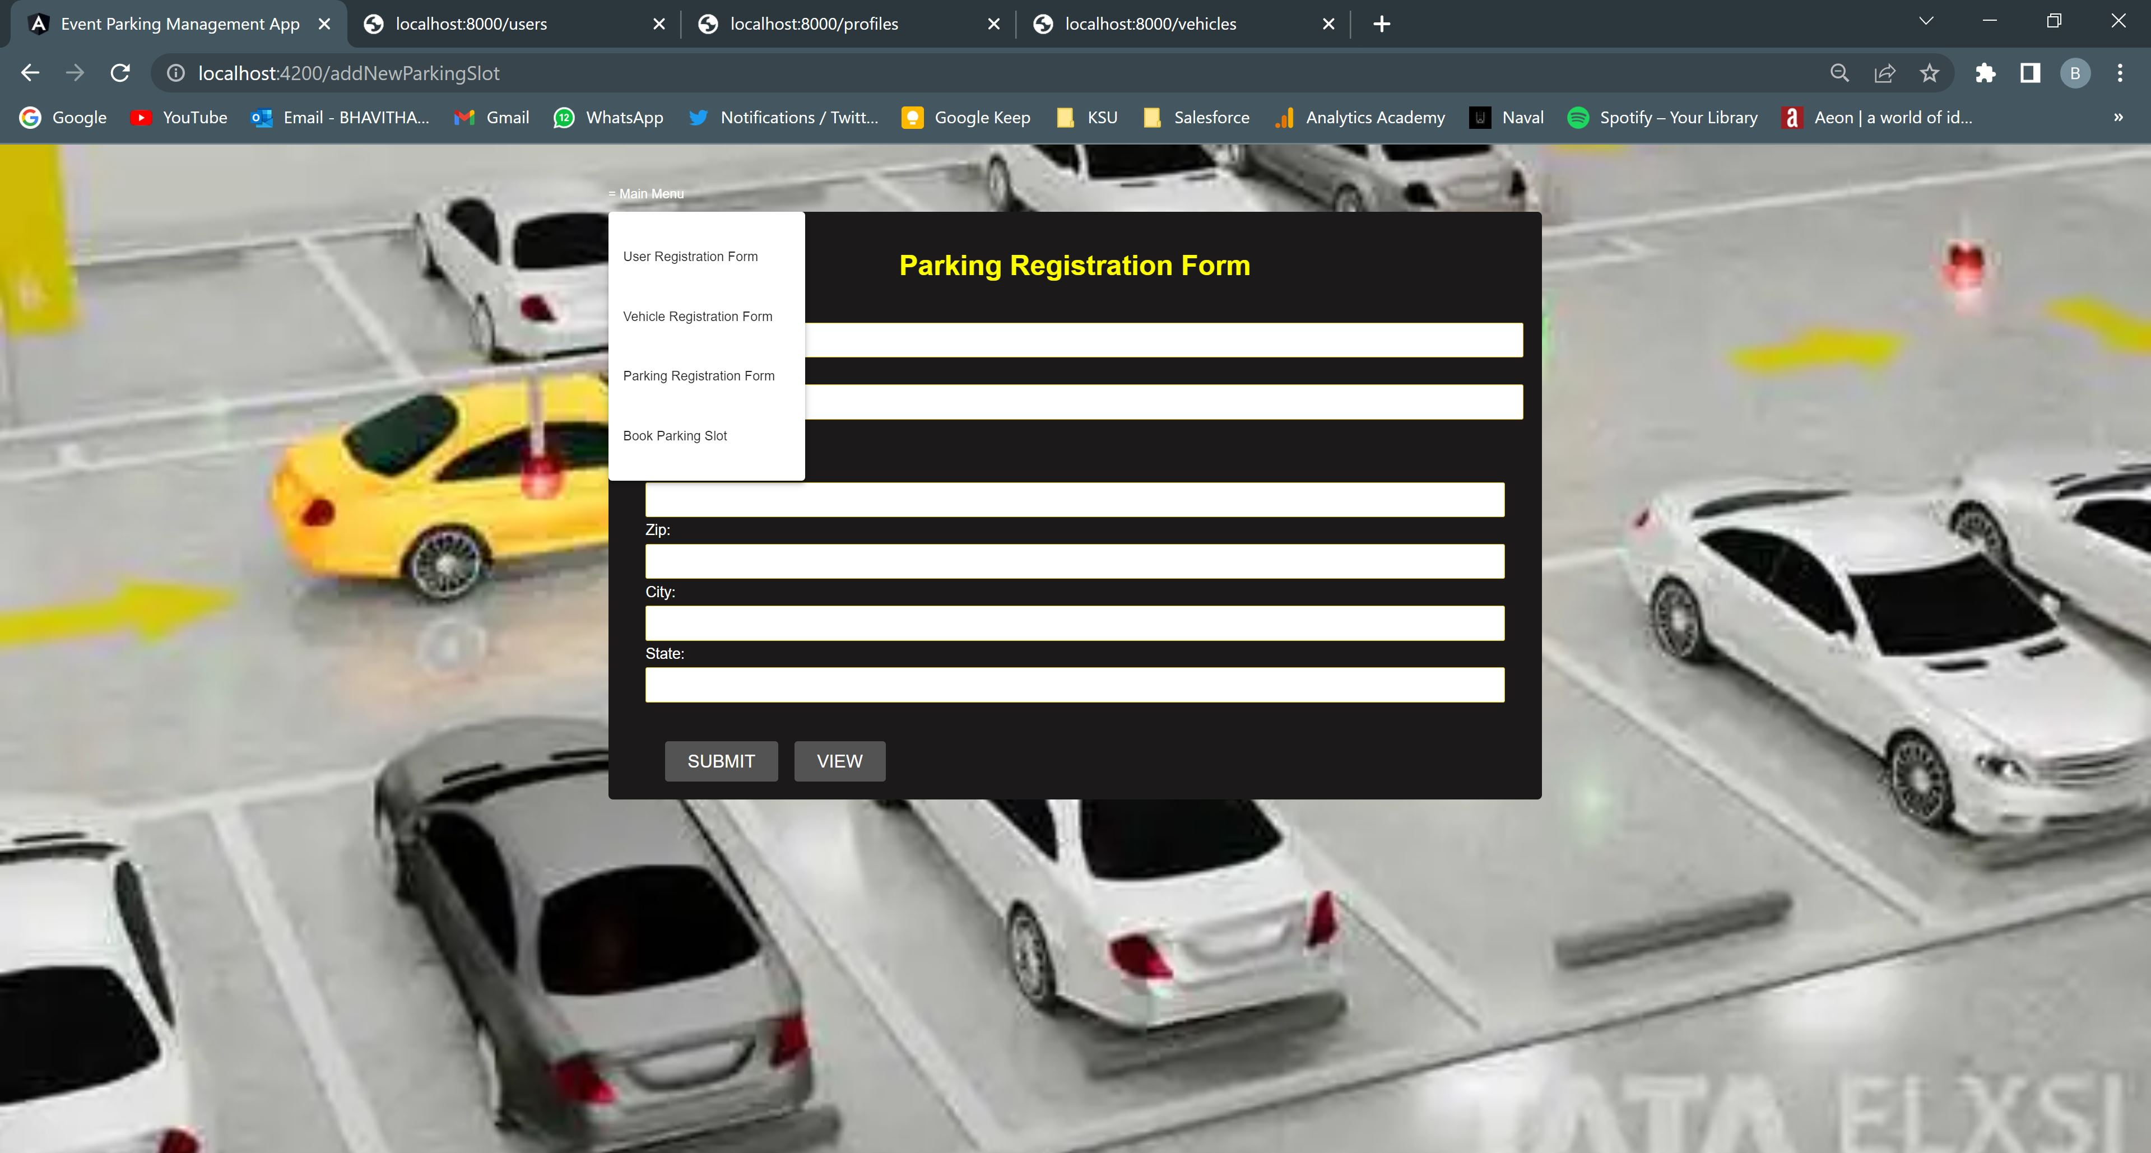

## Parking Registration Form

### Add New Parking

New parking slots can be created for users in different locations and buildings. Create Button gets enabled once all the information is given.

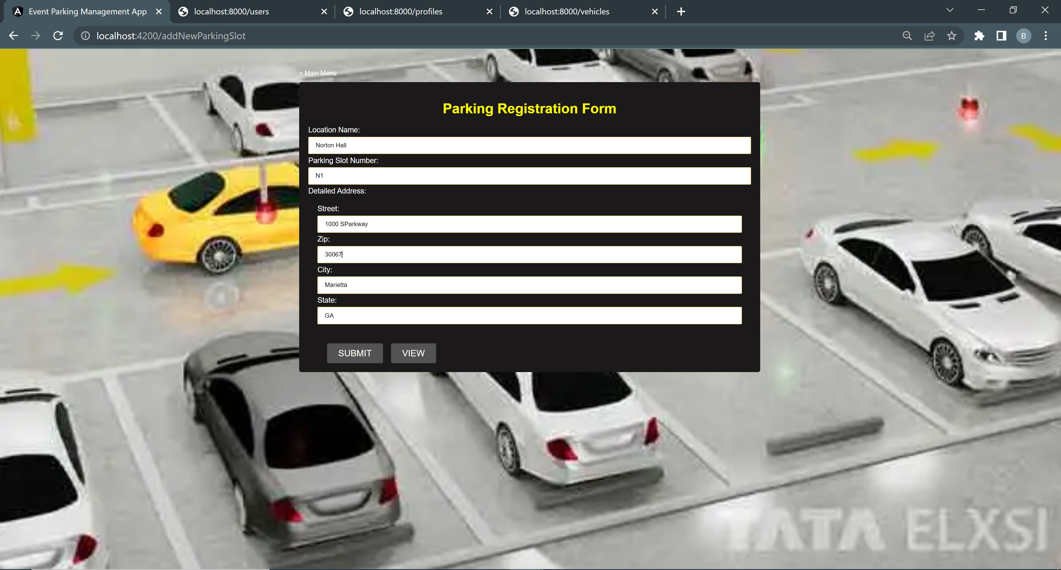

### View Added Parking

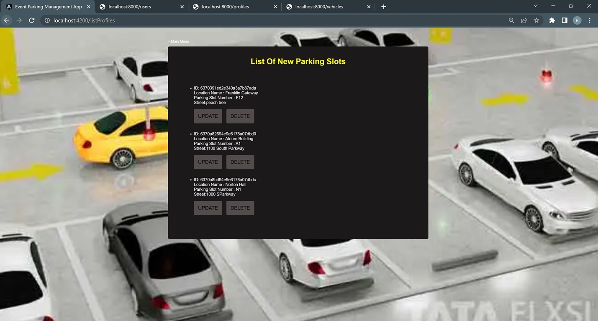

### Update Parking Information

Click on update button to update parking information. Here,after update, the street and parking slot number information of ID:6370391ed2e340a3a7b87ada [Franklin Gateway] are successfully updated

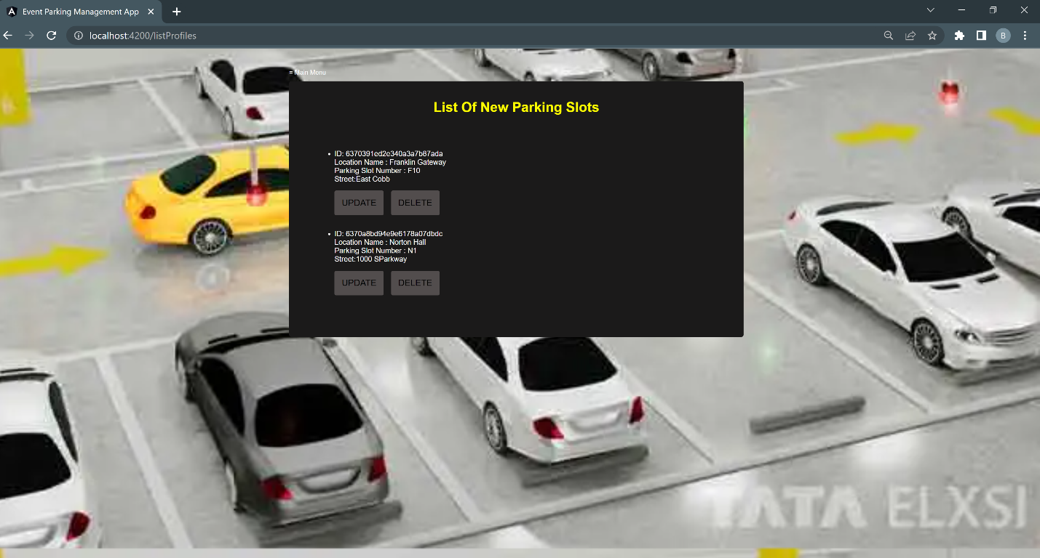

### Delete Parking Information

Click on the Delete button to delete the added parking slot. Here we have deleted parking slot with ID : 6370a82694e6178a07dbd0 [Atrium Building]

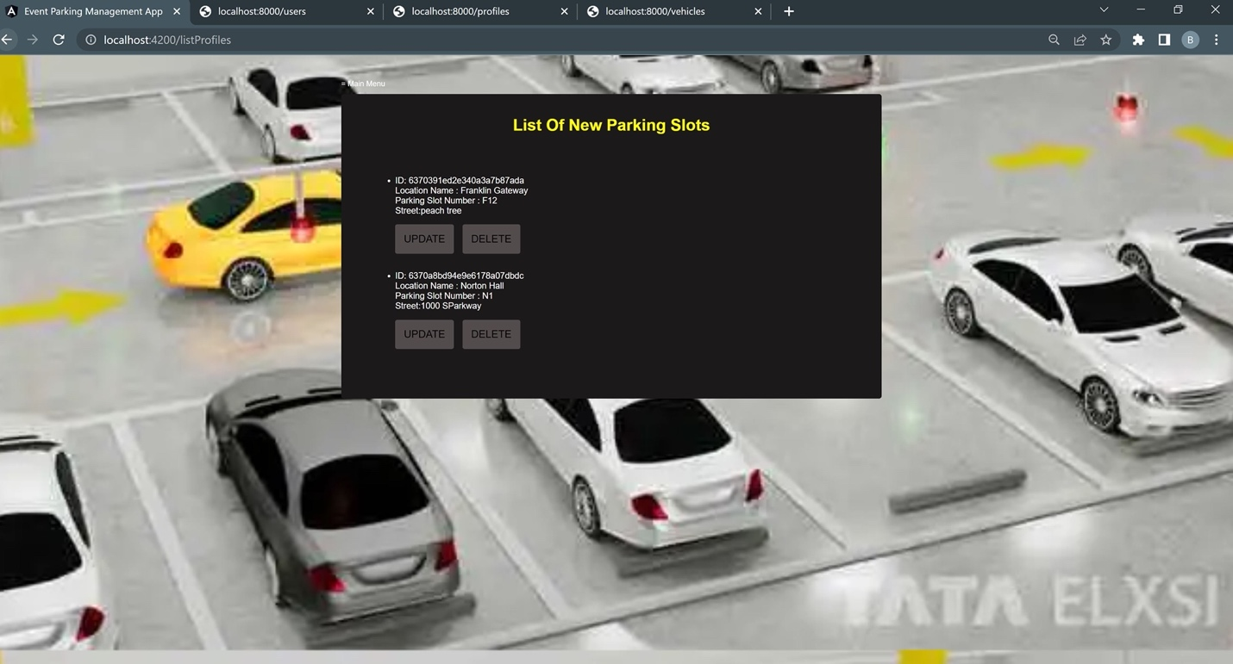

## User Registration Form

### Add New User

The new user must provide personal details as well as their address when registering. Once all information has been entered, user will be able to click the Submit button.

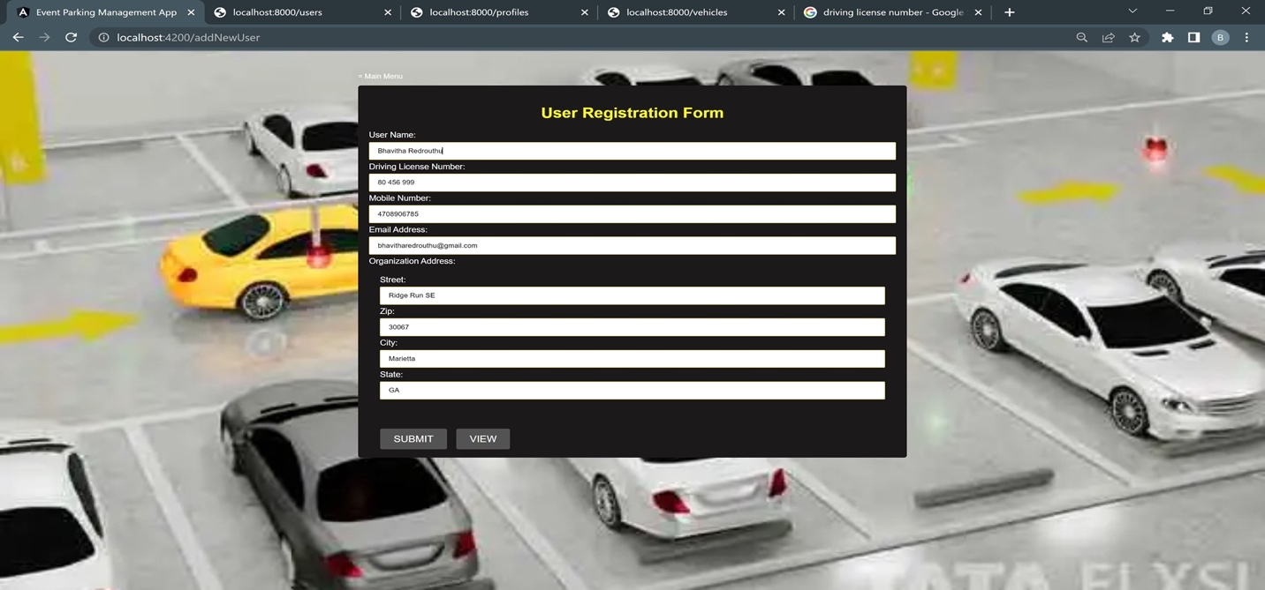

### View User Information

Click on view to display the details of added users.

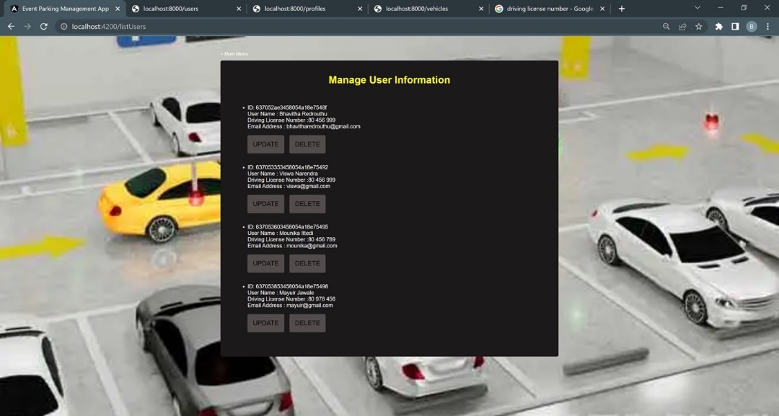

### Update User Information

Click on Update button to update the user information.

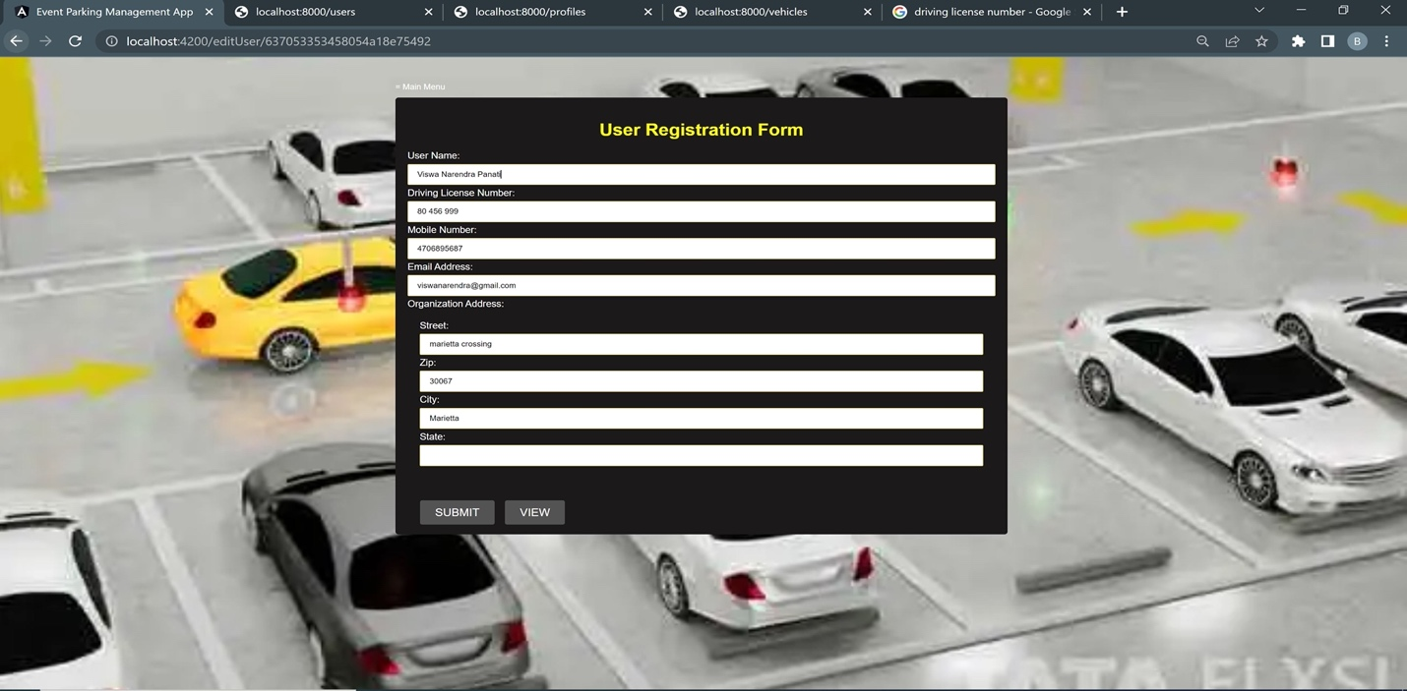

### Delete User Information

Click on the Delete button to delete the added user. Here we have successfully deleted

ID:637053603458054a18e75495.

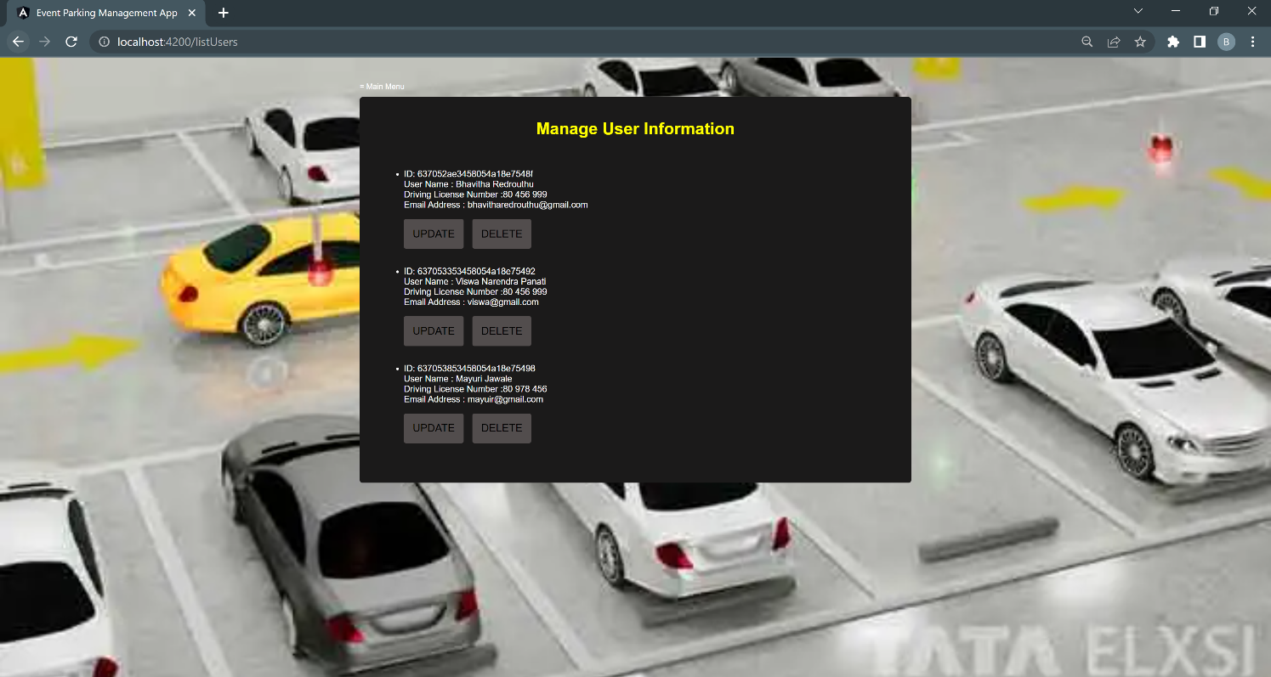

## Vehicle Registration Form

### Add New Vehicle

Add a new vehicle detail and click on submit button.

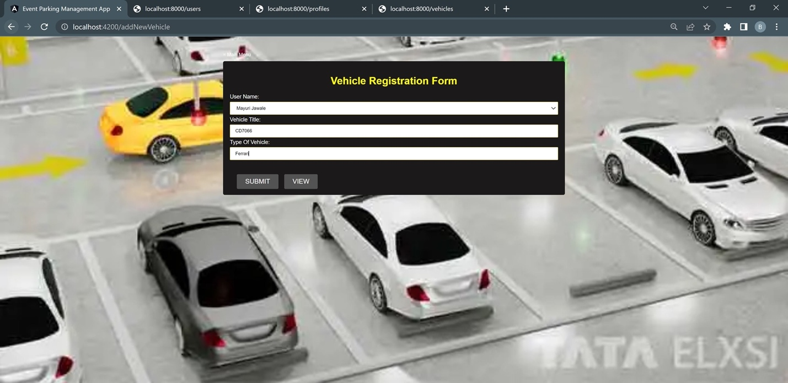

### View Vehicle Information

Click on view to display the details of added vehicles.

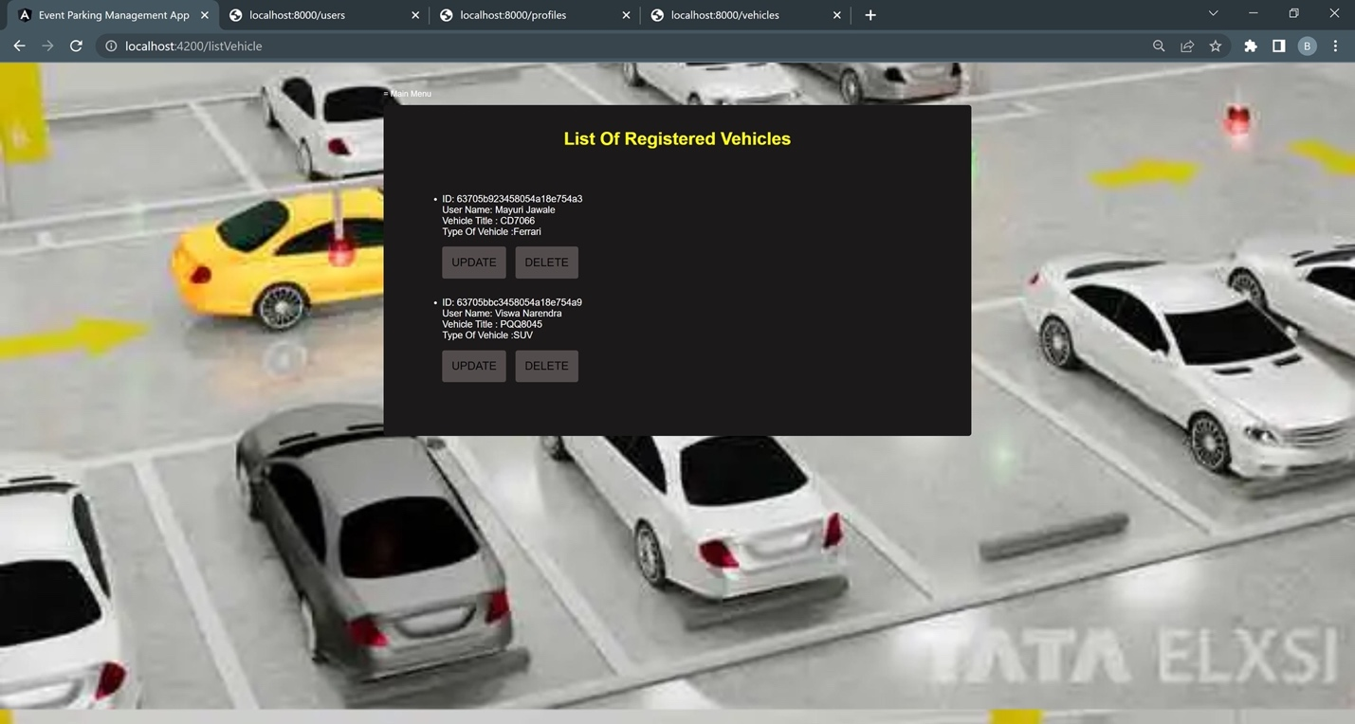

### Update Vehicle Information

Click on Update button to update the vehicle information.

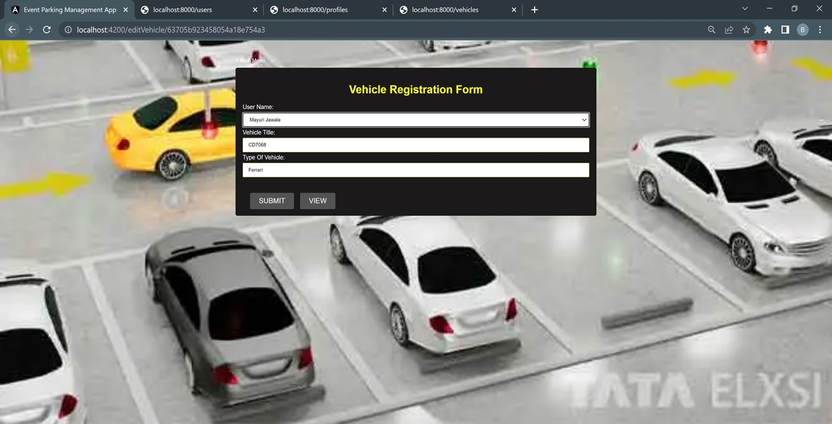

### Delete Vehicle Information

Click on the Delete button to delete the added vehicle. Here we have successfully deleted the ID:63705bbc3458054a18e754a9.

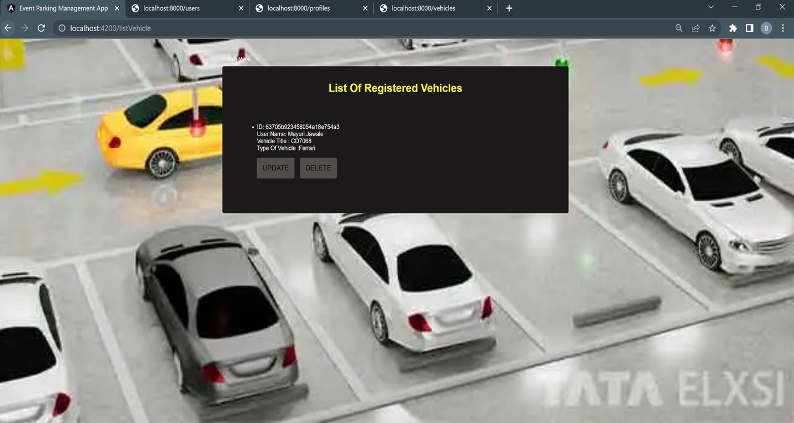

## Book Parking Slot

Users can Book parking slot after booking they can update their slot to new existing slots, they can leave the parking if it’s no longer required and can view their current booking real-time and they can get navigation from home to parking slot using google map API.

### Book Parking Slot

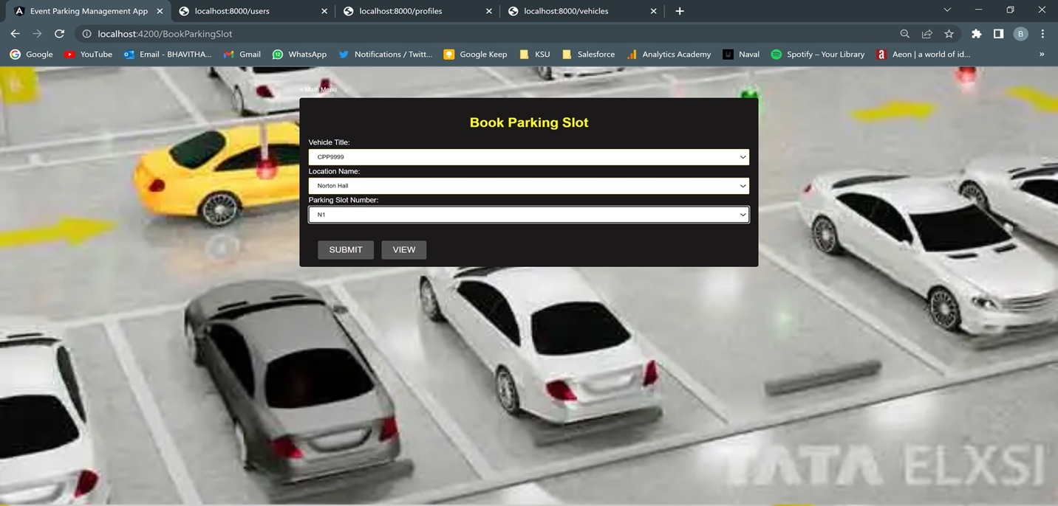

### View Parking Slots

Click on the view to display the details of parking slots.

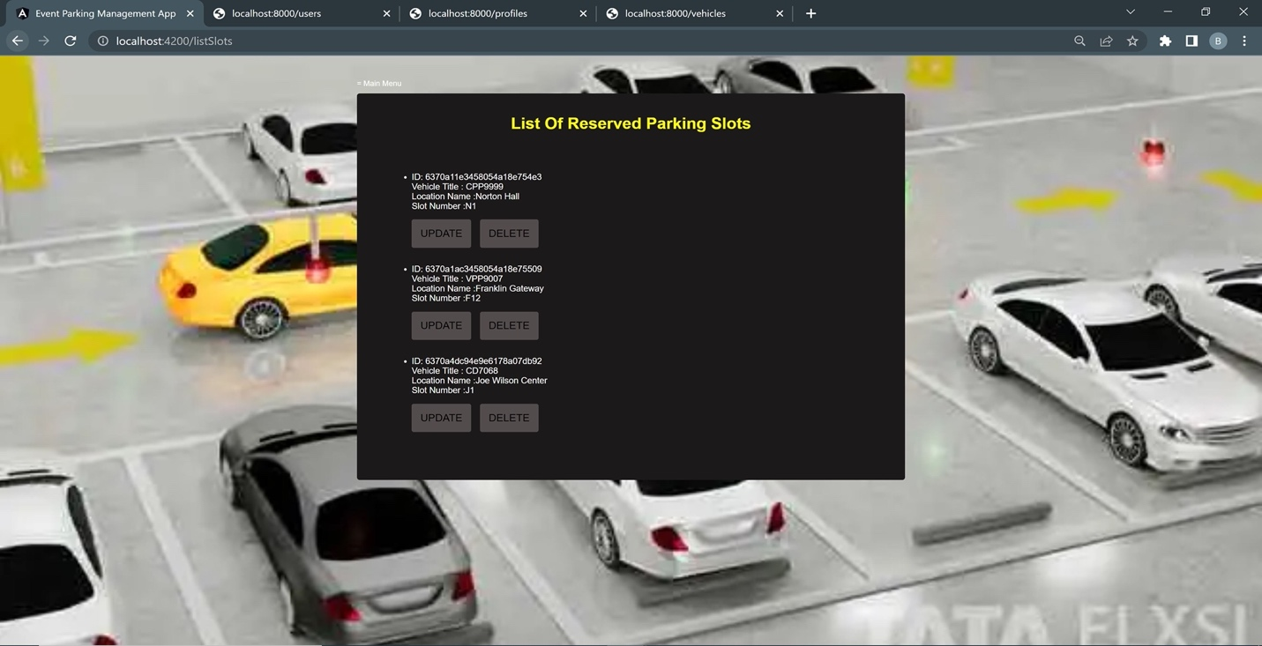

### Update Parking Slot information

Click on the Update button to update the parking slot information. Here if you see the highlighted ID,the location name and slot number are successfully updated.

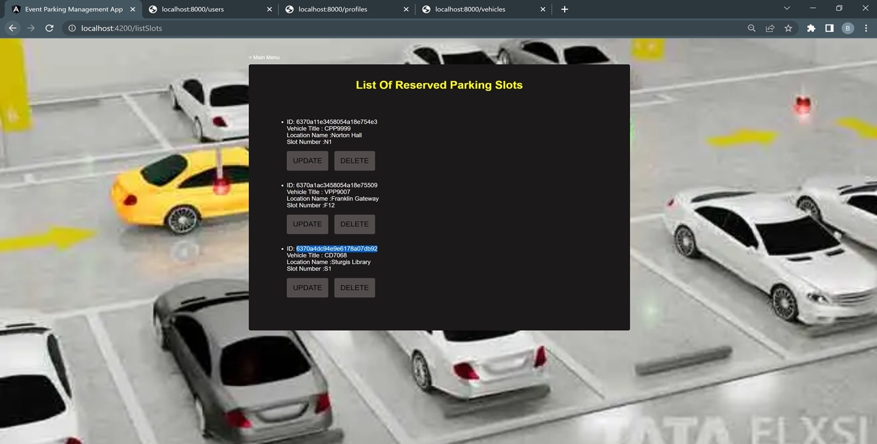

### Delete Parking Slot Information

Click on the Delete button to delete the assigned parking slot. Here ID:6370a1ac3458054a18e75509 has been successfully deleted.

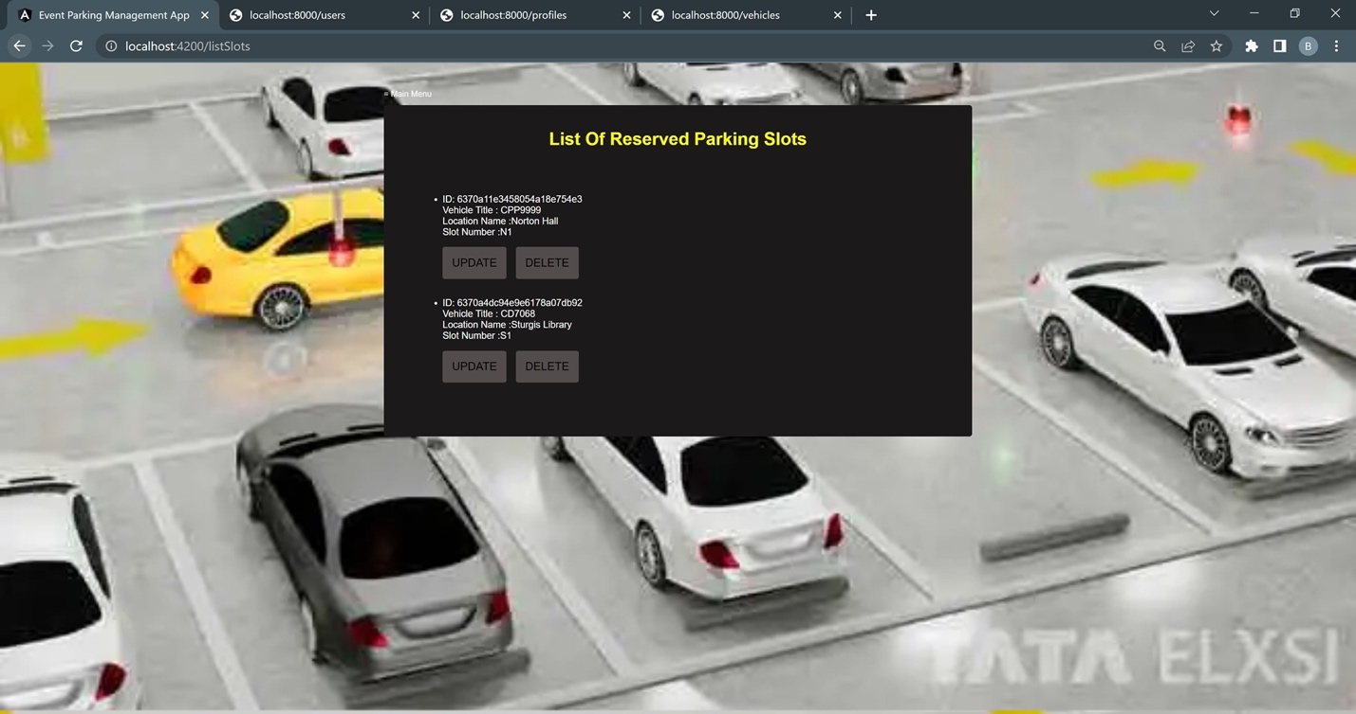

1. 3rd Party API Integration: [Google Maps]

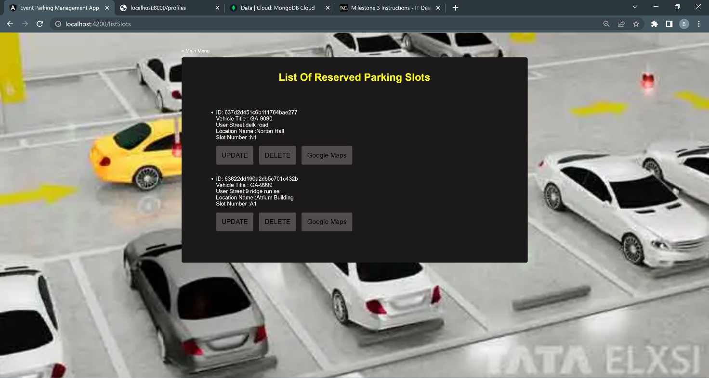

*After slot is reserved, user can re-direct to google maps to find the best route.

